

How to use the AQUBIO Service Tool

Version 1.0

**Document history:**

|  |  |  |  |
| --- | --- | --- | --- |
| **Date** | **Revision** | **Details** | **Author** |
| 23-Nov-2018 | 1.0 | Initialize version | Hien |
|  |  |  |  |
|  |  |  |  |
|  |  |  |  |
|  |  |  |  |
|  |  |  |  |

Table of Contents

I. Overview 1

II. Environment 1

III. Installation 1

IV. Launch the AQUBIO board 3

4.1 Hardware connections 3

4.2 Connect to PC 4

4.3 Software Installation 5

4.3.1 Tera Term setting 5

4.3.2 STM32 ST-LINK Utility setting 6

4.4 Download firmware to AQUBIO board 8

4.5 Update firmware via Wi-fi hotspot 10

V. Launch the app 10

5.1 Prepare for run app 10

5.2 Launch Application 13

5.3 Connect board via Bluetooth 16

5.4 Update firmware via Wi-fi hotspot 17

**Table of Figures**

Figure 1 - Install the application 1

Figure 2 - Accept all permissions 2

Figure 3 - Create wi-fi hotspot 3

Figure 4 - Config for wi-fi hotspot 4

Figure 5 - Login screen 5

Figure 6 - Excute and connect Bluetooth 6

Figure 7 - Time out Bluetooth 7

Figure 8 - Verify PIN code 8

Figure 9 - AQUBIO authentication complete 9

Figure 10 - Chose file update 10

Figure 11 - Send data update firmware 11

Figure 12 - AQUBIO download complete 12

Figure 13 - Hardware connections 13

Figure 14 - ST Link connection 14

Figure 15 - Tera Term setting 15

Figure 16 - STM32 ST-LINK Utility setting 16

Figure 17 - STM32 ST-LINK connected to device 17

Figure 18 - Select firmware 18

Figure 19 - Download firmware 18

Figure 20 - Tera Term log 19

Figure 21 - AQUBIO setup new firmware 20

**I. Overview**

The AQUBIO Service Tool is an application on Android phone which is used to communicate with AQUBIO board via Bluetooth and Wifi.

**II. Environment**

|  |  |  |  |
| --- | --- | --- | --- |
| **No.** | **Device** | **Quantity** | **Note** |
| 1 | Android Phone | 01 | OS 5.0 or higher |
| 2 | AQUBIO board | 01 | STM32F765VI |

# III. Installation

Open file manager and choose file AQUBIO_service_tool.apk to install .

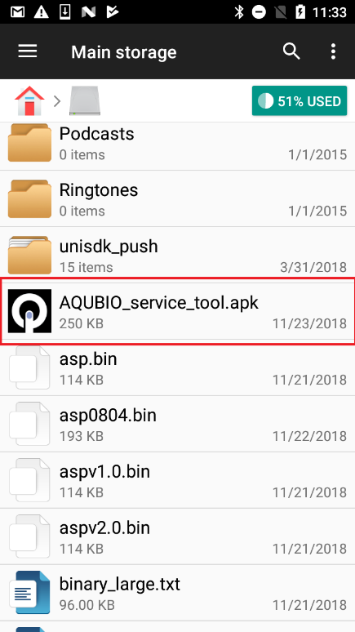 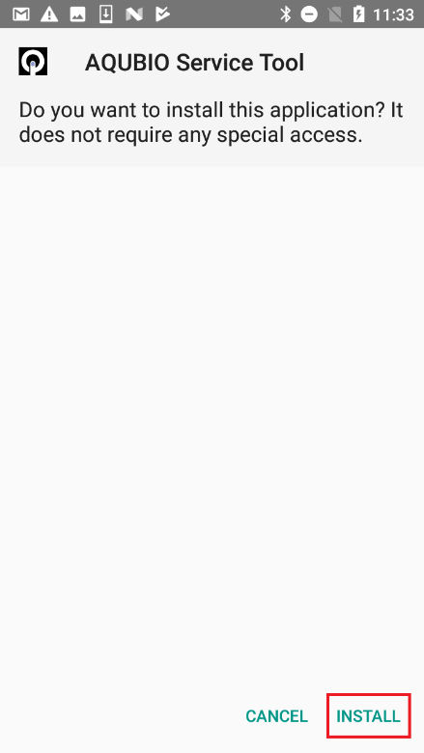 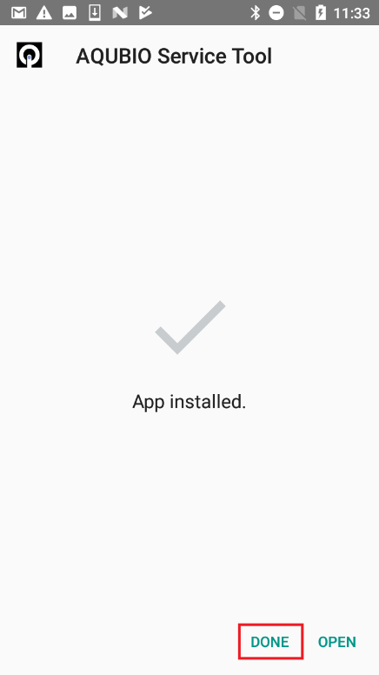

Figure 1 - Install the application

After installation finishes, make sure all permission are enabled by the way as below :

Go to setting on phone, chose applications, touch on AQUBIO Service Tool to manager

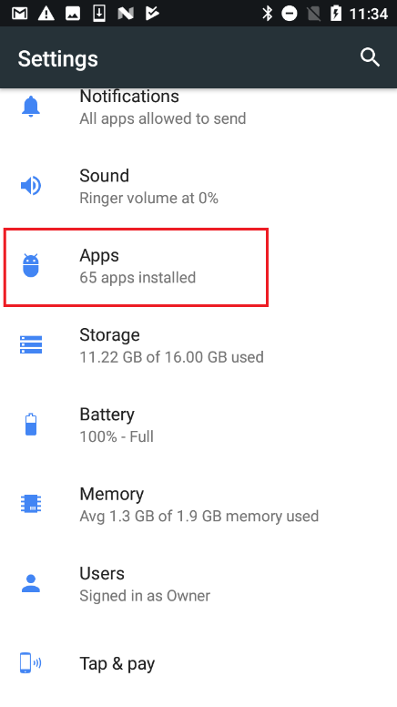 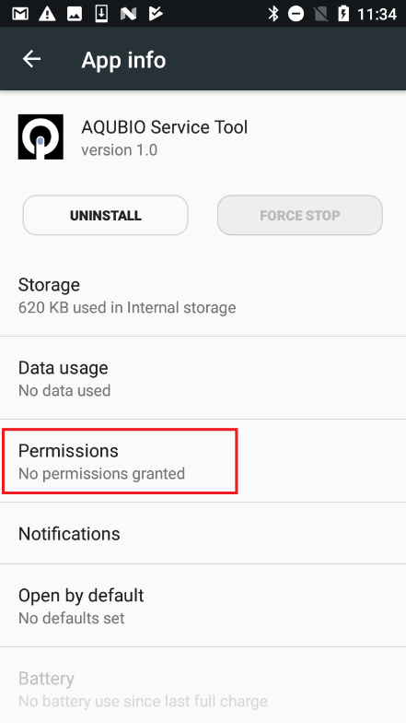 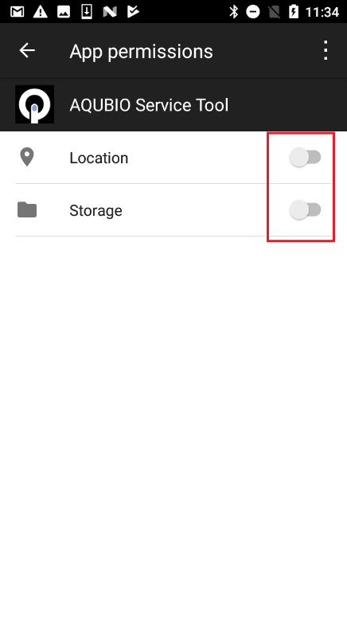

Figure 2 - Accept all permissions

# IV. Launch the AQUBIO board

## 4.1 Hardware connections

|  |  |
| --- | --- |
| **内包物:** |  |
| 認証機 | 1 |
| ST-LINK | 1 |
| WIFI基板 | 1 |
| USB-シリアル変換基板 | 1 |

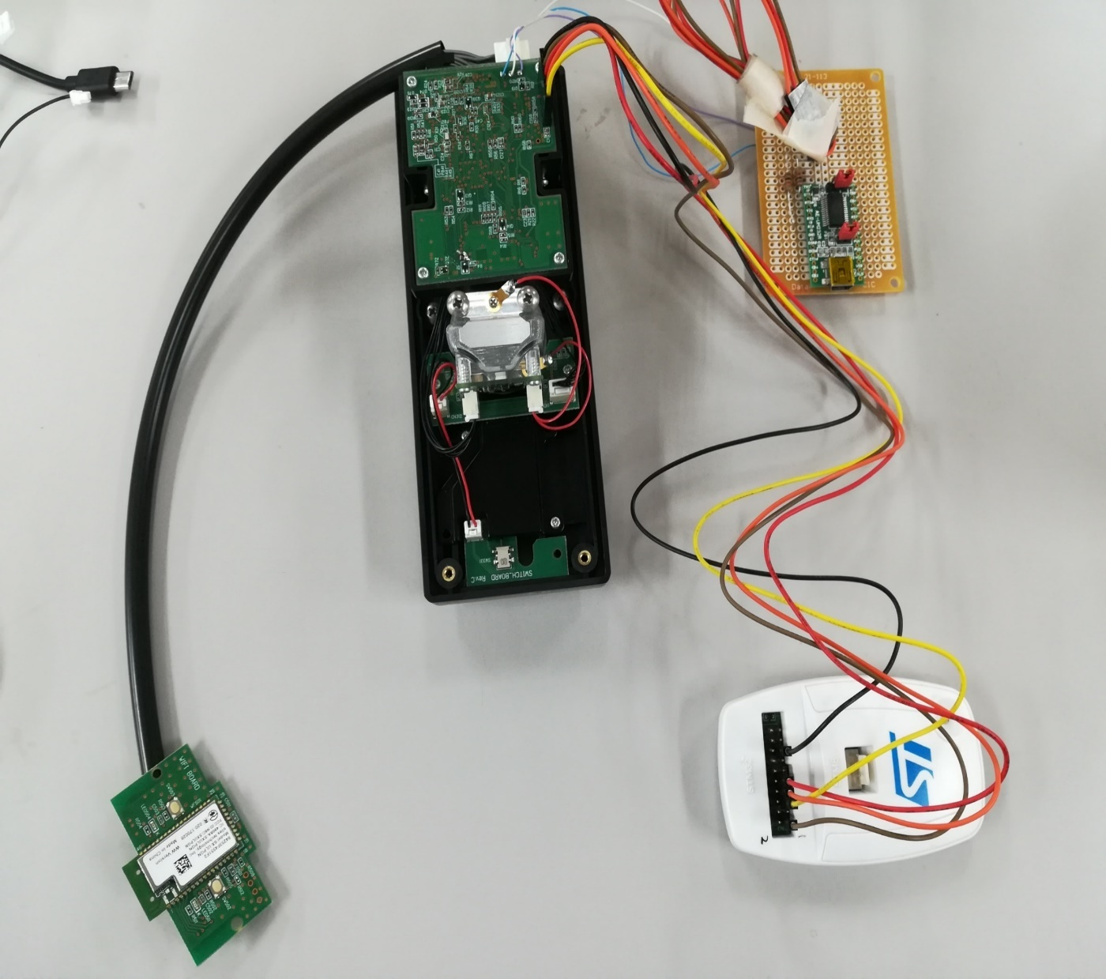

WIFI基板

USB-シリアル変換基板

ST-LINK

認証機

Figure 3 - Hardware connections

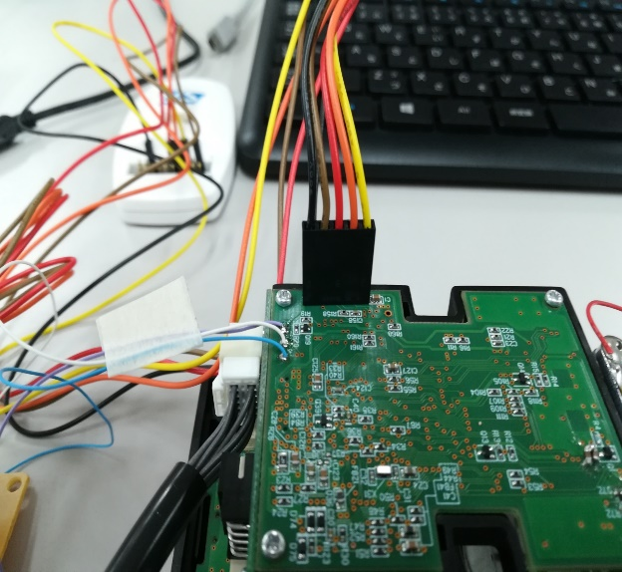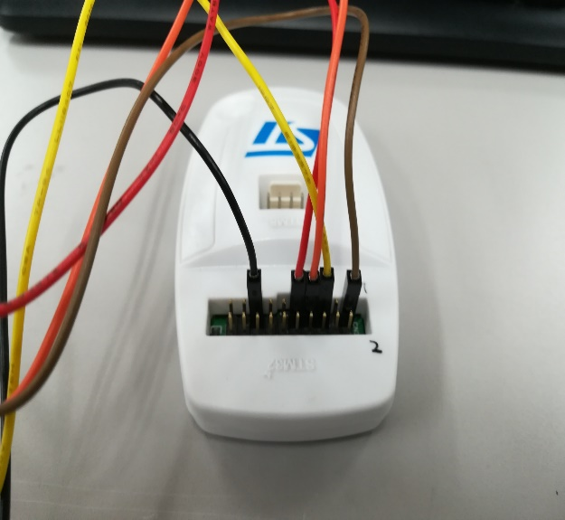

Figure 4 - ST Link connection

## 4.2 Connect to PC

Connect AQUBIO board to PC via port on the top by USB 2.0 type A – mini B cable

Connect ST-Link to PC by USB 2.0 type A – mini B cable

Connect USB-Serial UART to PC by USB 2.0 type A – mini B cable

## 4.3 Software Installation

Tera Term – Version 4.100

STM32 ST-LINK Utility – Version 4.2.0.0

### 4.3.1 Tera Term setting

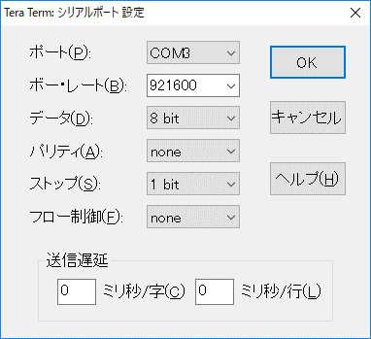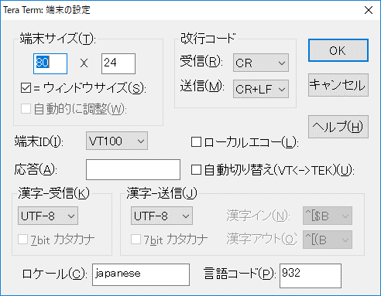

Figure 5 - Tera Term setting

### 4.3.2 STM32 ST-LINK Utility setting

Select Target 🡪 Settings …

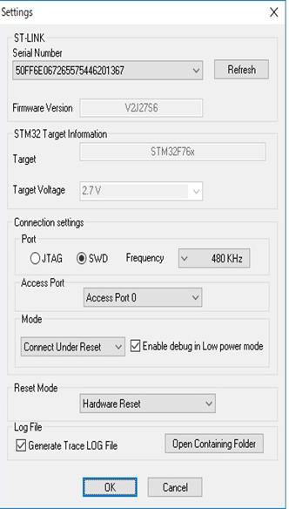

Figure 6 - STM32 ST-LINK Utility setting

Press OK to connect device

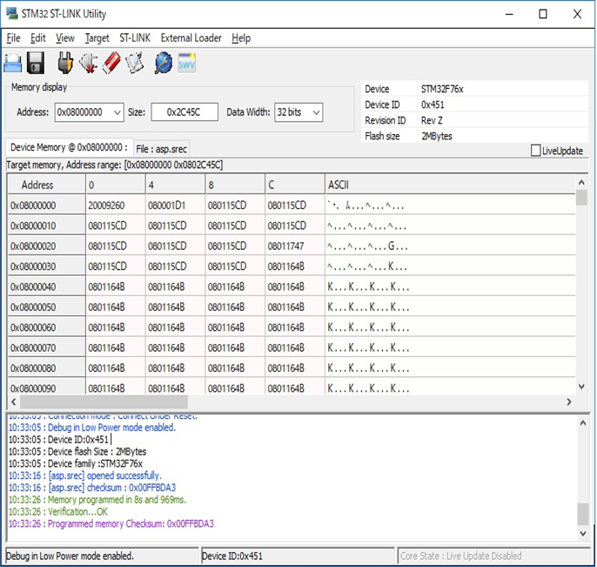

10:32:54 : No ST-LINK detected

10:33:05 : ST-LINK SN : 50FF6E067265575446201367

10:33:05 : ST-LINK Firmware version : V2J27S6

10:33:05 : Connected via SWD.

10:33:05 : SWD Frequency = 480 KHz.

10:33:05 : Connection mode : Connect Under Reset.

10:33:05 : Debug in Low Power mode enabled.

10:33:05 : Device ID:0x451

10:33:05 : Device flash Size : 2MBytes

10:33:05 : Device family :STM32F76x

10:33:16 : [asp.srec] opened successfully.

10:33:16 : [asp.srec] checksum : 0x00FFBDA3

10:33:26 : Memory programmed in 8s and 969ms.

10:33:26 : Verification...OK

10:33:26 : Programmed memory Checksum: 0x00FFBDA3

10:45:39 : ST-LINK SN : 50FF6E067265575446201367

10:45:39 : ST-LINK Firmware version : V2J27S6

10:45:39 : Connected via SWD.

10:45:39 : SWD Frequency = 480 KHz.

10:45:39 : Connection mode : Connect Under Reset.

10:45:39 : Debug in Low Power mode enabled.

10:45:39 : Device ID:0x451

10:45:39 : Device flash Size : 2MBytes

10:45:39 : Device family :STM32F76x

Figure 7 - STM32 ST-LINK connected to device

## 4.4 Download firmware to AQUBIO board

Open Tera Term and connect to Serial port (COM8)

Open STM32 ST-LINK Utility, select Target 🡪 Program & Verify … or press CTRL+P

Change directory to the folder containing the firmware (.srec file), select and open it

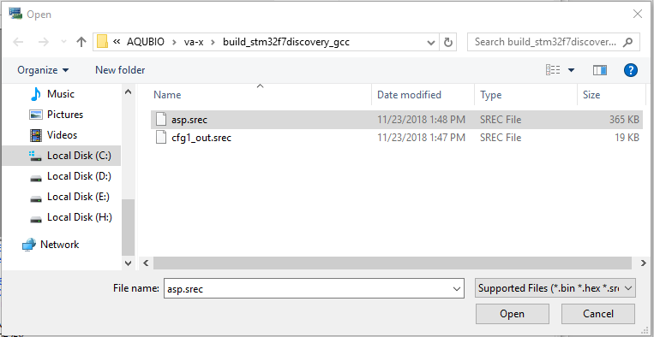

Figure 8 - Select firmware

Press Start and wait for download

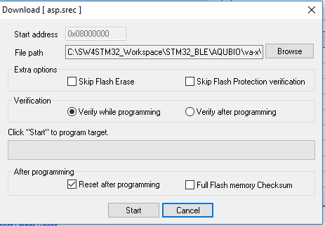

Figure 9 - Download firmware

## 4.5 Start AQUBIO board

After the firmware is downloaded, the AQUBIO resets and starts running the firmware.

We could see that the Version is 1.0.

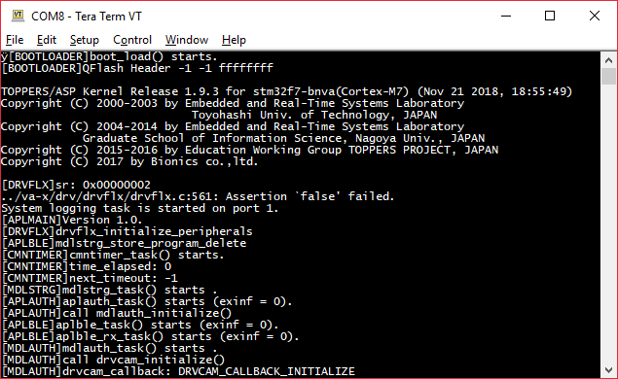

Figure 10 - AQUBIO bootup

Wait for the board to boot up and initilize the peripherals.

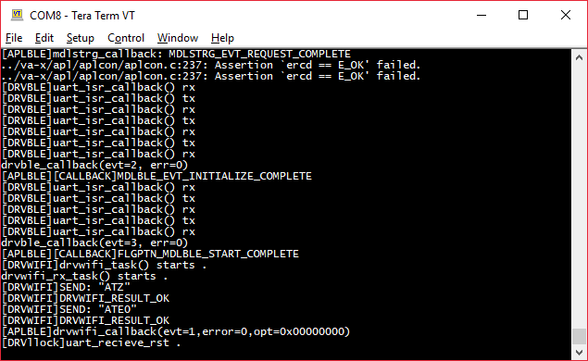

Figure 11 - AQUBIO bootup completed

# V. Launch the app

## 5.1 Prepare to run app

Make sure Bluetooth and hotspot are enabled.

Create a hotspot as below :

Go to setting on phone, and choose tethering & portable hotspot, wi-fi hotspot.

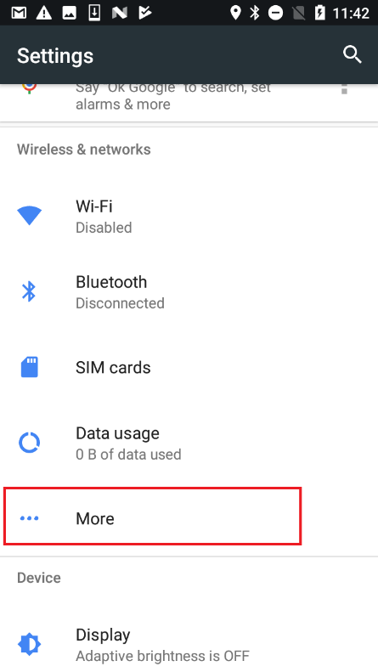 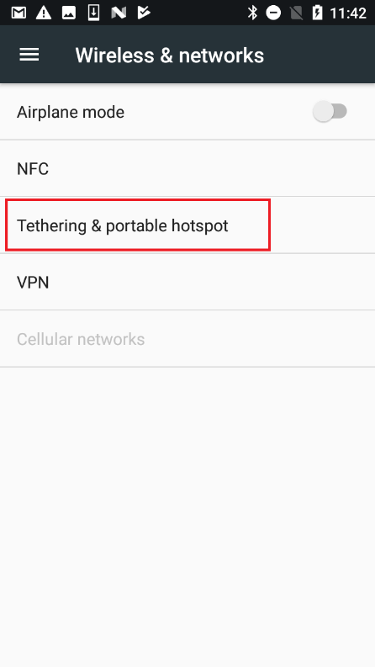 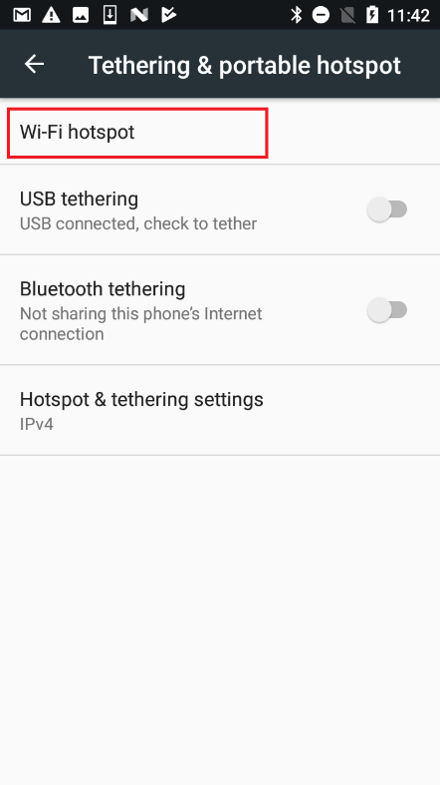

Figure 12 - Create wi-fi hotspot

Create and configure the wi-fi hotspot:

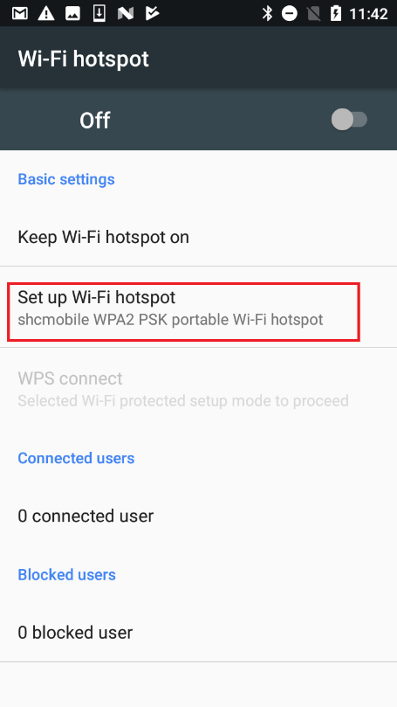 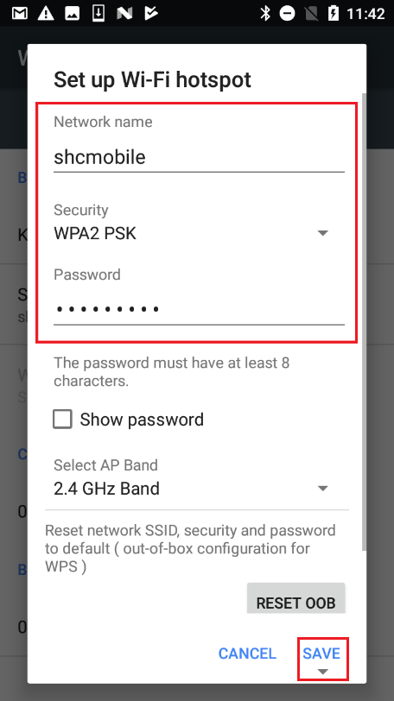 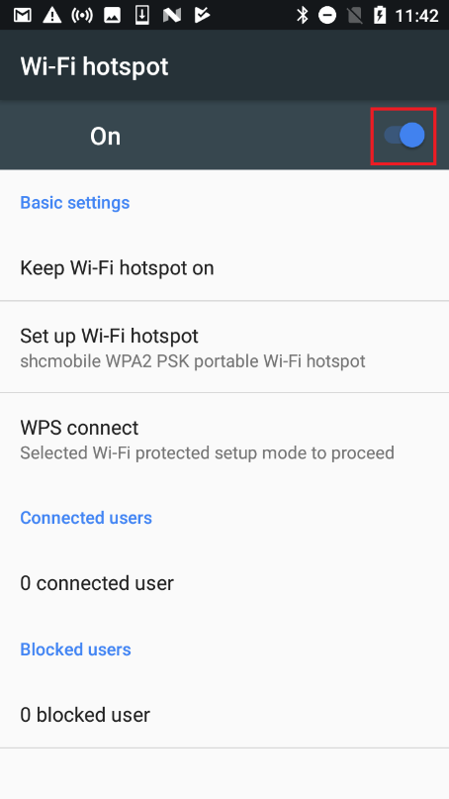

Figure 13 - Configuration for wi-fi hotspot

## 5.2 Launch Application

At Login Screen, user can change language on right-top display.

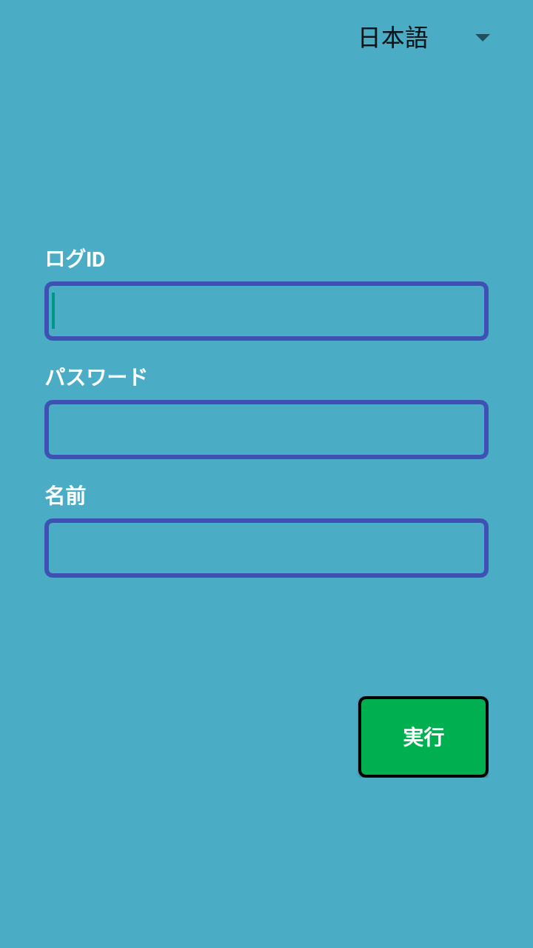

Figure 14 - Login screen

Input ID,password and name ,after that touch on button “実行”(Excute) to connect AQUBIO board via Bluetooth

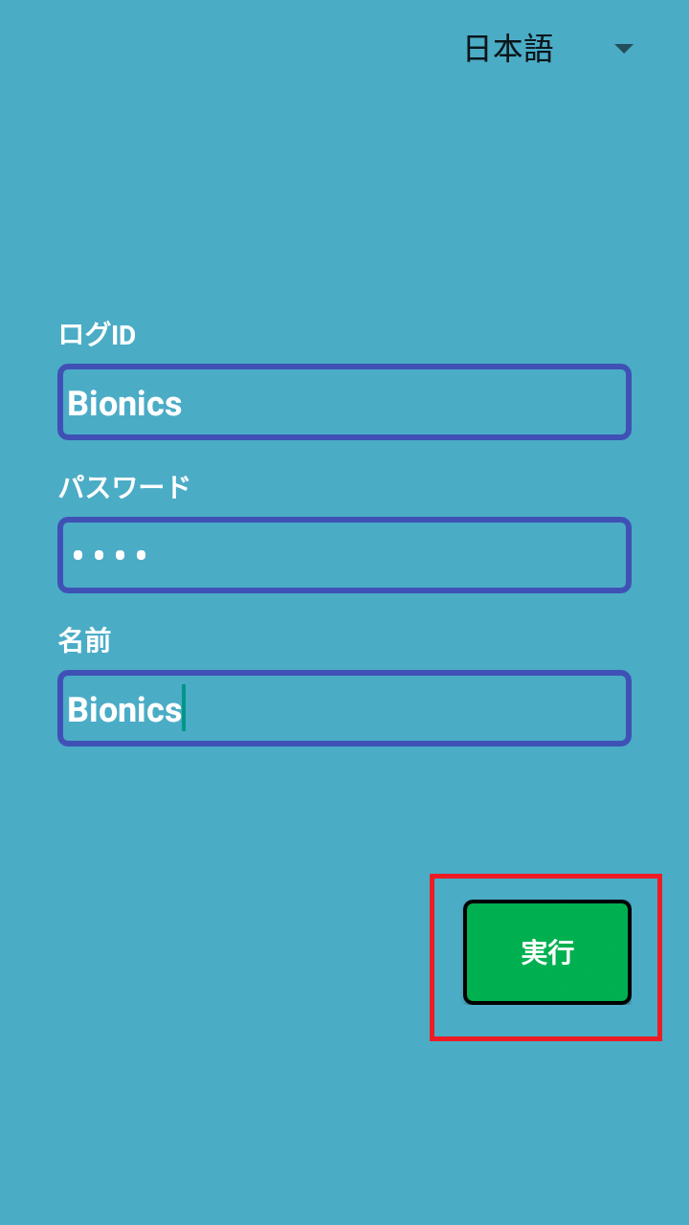

Figure 15 - Excute and connect Bluetooth

The app have notice to user when can not found board. The timeout to connect is 30 seconds

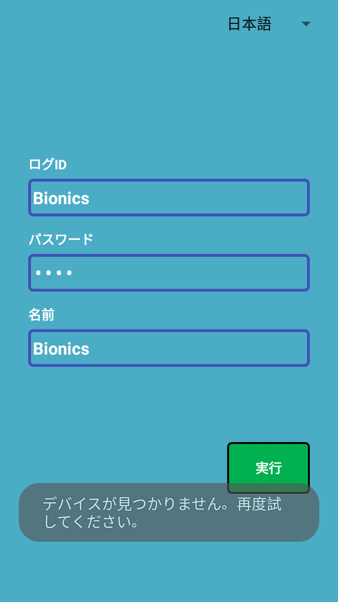

Figure 16 - Time out Bluetooth

## 5.3 Connect board via Bluetooth

With the correct of value ID, Pass, Name, the app will start connecting to the board via Bluetooth. And it will ask for the PIN code every time it connects to the board via Bluetooth

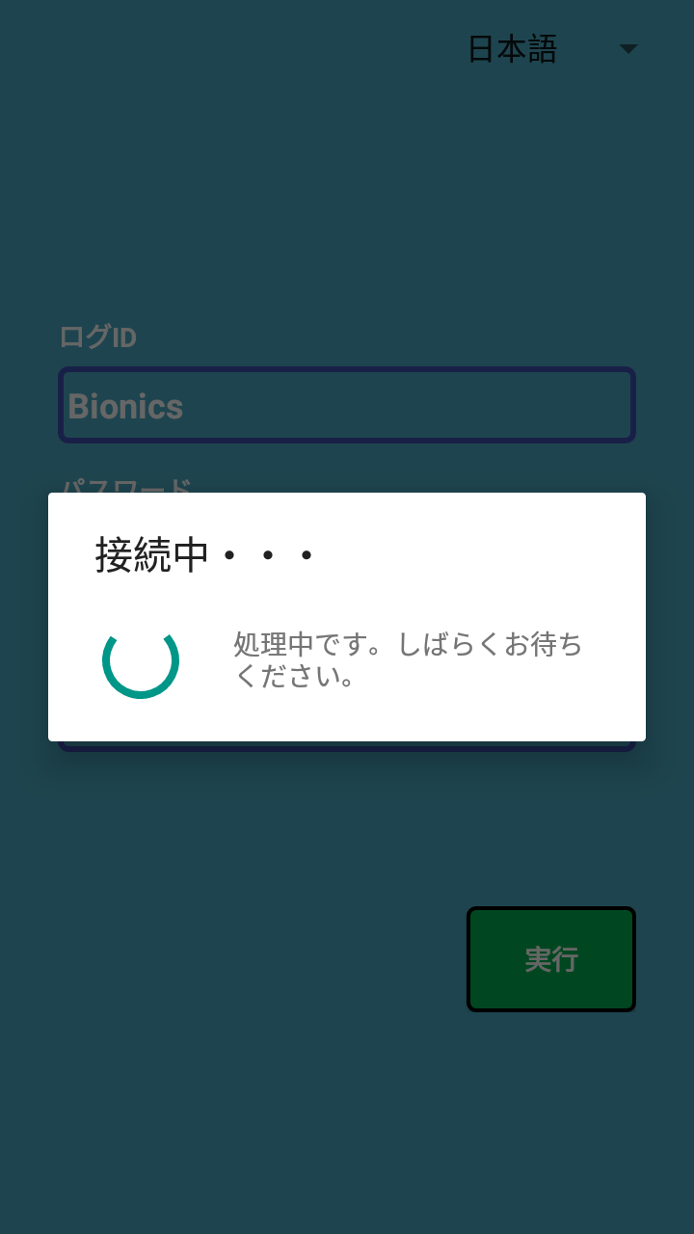 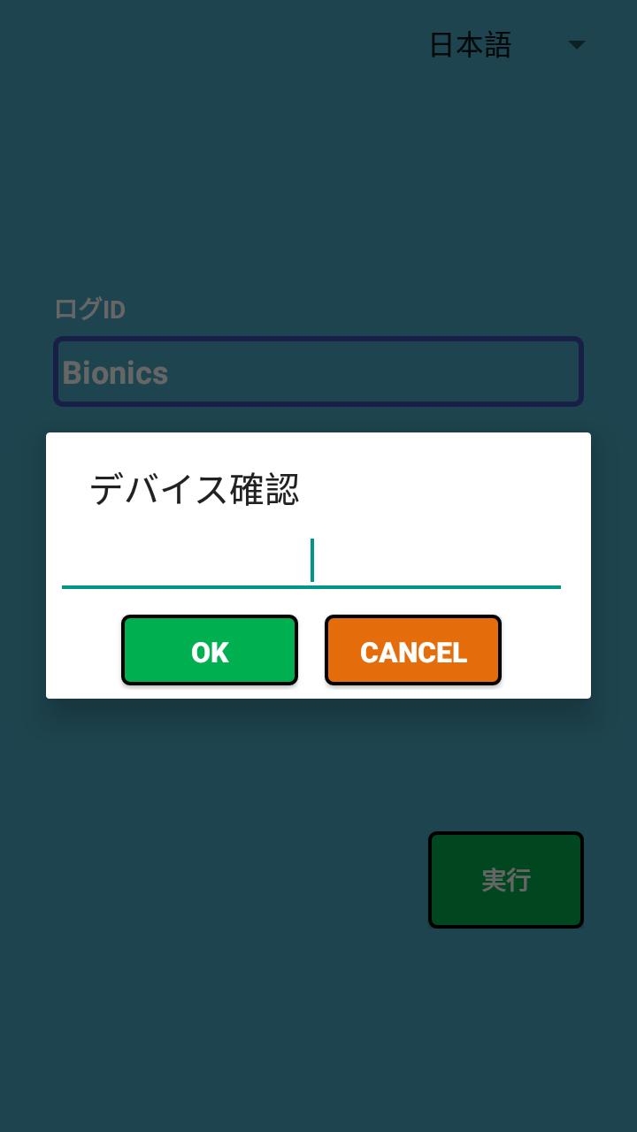

Figure 17 - Verify PIN code

If the PIN code is verified successfully, we will get the log as below:

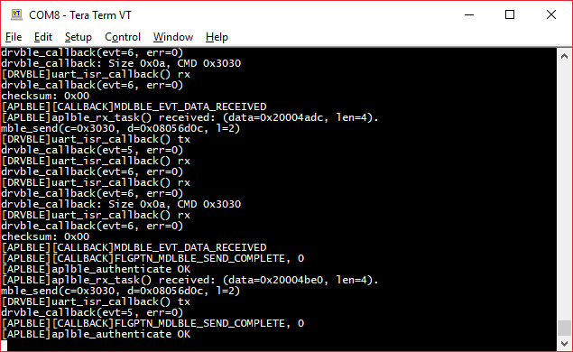

Figure 18 - AQUBIO authentication completed

## 5.4 Update firmware via Wi-fi hotspot

After connect via Bluetooth, the app will move to version up screen.

User can choose firmware file and send to AQUBIO board to update firmware here.

User must enter SSID and password of wi-fi hotspot before choosing file.

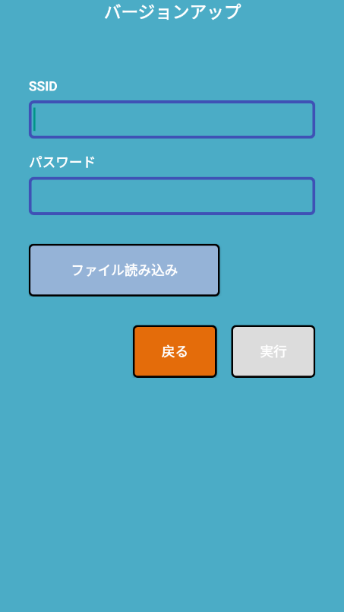 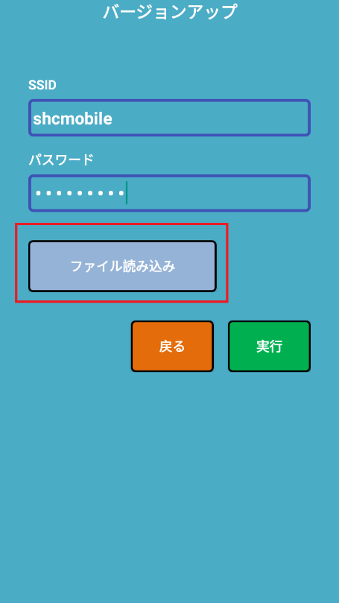 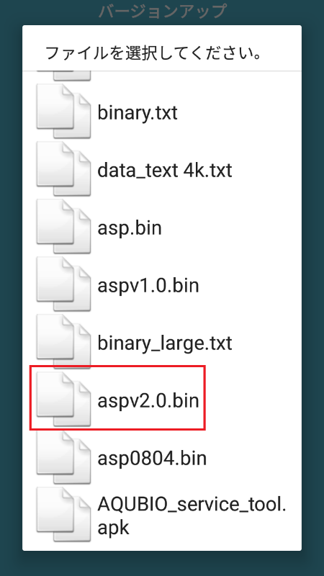

Figure 19 - Choose file to update

Touch on button “実行”(Send file) to start sendind data to AQUBIO board.

The app will wait for the board to connect to wifi hotspot.

Then it will start to transfer firmware to the board.

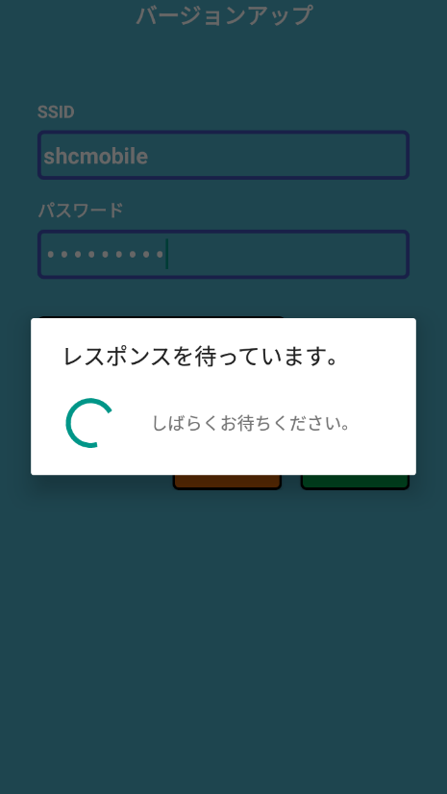 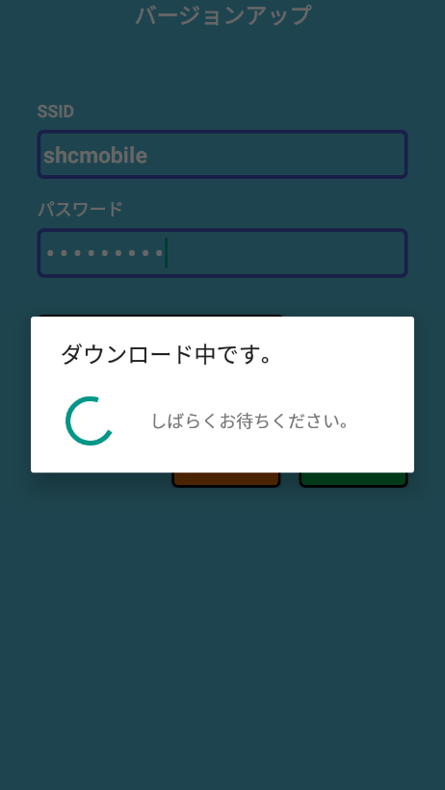 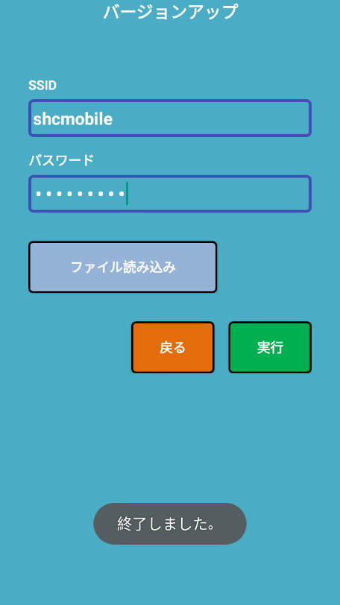

Figure 20 - Send data update firmware

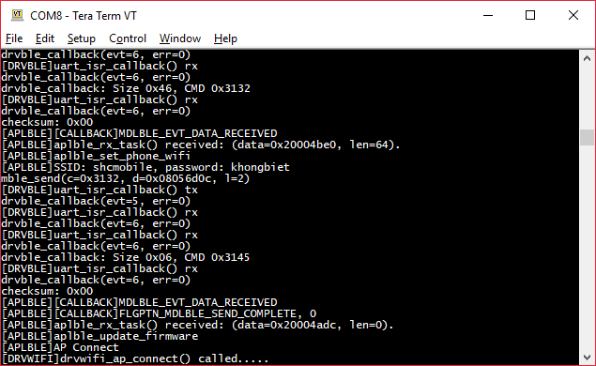

Figure 21 - AQUBIO receive firmware update command

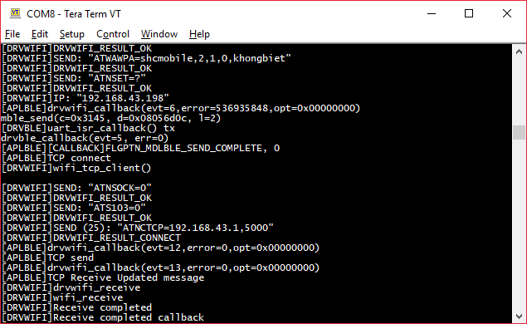

Figure 22 - AQUBIO connect to wifi hotspot successfully

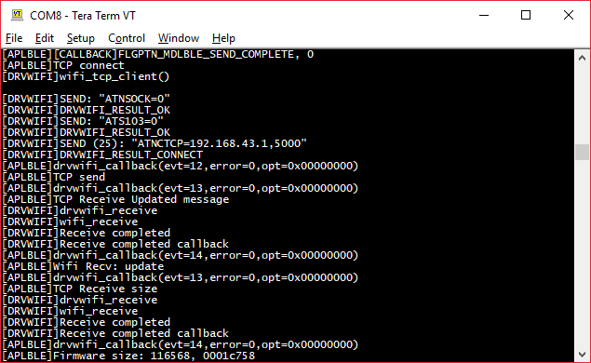

Figure 23 - AQUBIO receive firmware size

If the firmware size is larger than 4096 bytes, it will be divided into multiple packages. Each package contains 4096 bytes.

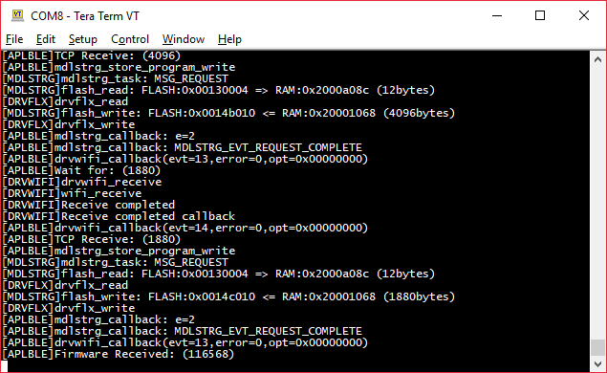

Figure 24 - AQUBIO download complete

When download finish, reset AQUBIO to run new firmware.

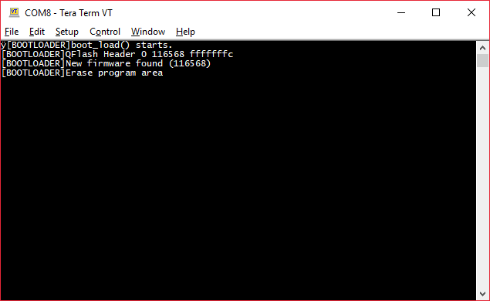

Figure 25 - AQUBIO is copying firmware from external flash to internal flash

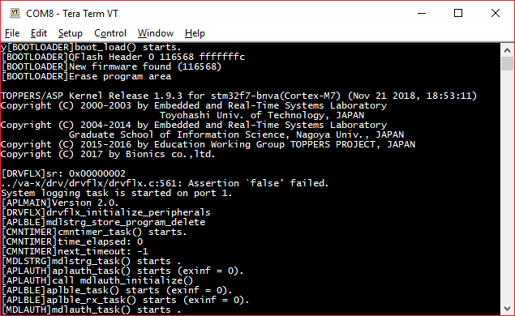

Figure 26 - AQUBIO starts new firmware